(Day-13 afternoon session)

1.Write a program to create a arraylist of double element and add the elements.

sort the elements in descending order and print it.

package SBA_1;

import java.util.ArrayList;

import java.util.Collections;

import java.util.List;

public class Q1 {

public static void main(String[] args) {

List<Double> list2=new ArrayList<Double>();

list2.add(21.22);

list2.add(11.22);

list2.add(16.22);

list2.add(26.22);

Collections.sort(list2,Collections.reverseOrder());

System.out.println("Array elements in descending order");

for(Double number:list2)

System.out.println(number);

}

}

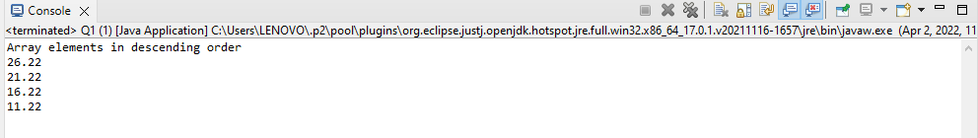

2.Create a arraylist of integers and find the sum and average of the entire list.

package SBA_1;

import java.util.ArrayList;

import java.util.List;

public class Q2 {

public static void main(String[] args) {

List<Integer> list=new ArrayList<Integer>();

list.add(21);

list.add(11);

list.add(51);

list.add(1);

int sum=0;

for(int i:list)

sum=sum+i;

System.out.println("Sum = "+sum);

int avg=sum/list.size();

System.out.println("Average = "+avg);

}

}

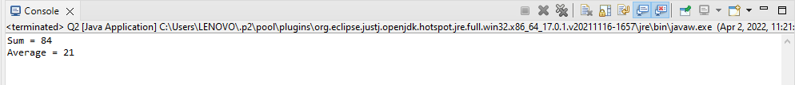

3.Create two arraylist of strings to take First_name and Last_name of the students,

and print their whole name.

package SBA_1;

import java.util.ArrayList;

import java.util.Scanner;

public class Q3 {

public static void main(String[] args) {

Scanner sc=new Scanner(System.in);

System.out.println("Enter number of students");

int n=sc.nextInt();

ArrayList<String> first_name=new ArrayList<String>();

ArrayList<String> second_name=new ArrayList<String>();

for(int i=1;i<=n;i++)

{

System.out.println("Enter first name of student no."+i);

first_name.add(sc.next());

System.out.println("Enter second name of student no."+i);

second_name.add(sc.next());

}

for(int i=0;i<n;i++)

{

System.out.println("Full name of student no."+(i+1)+"= "+first_name.get(i)+" "+second_name.get(i));

}

}

}

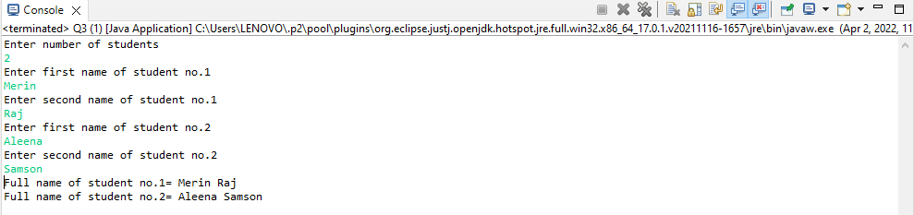

(day-8 assignment)

4.Write a program to check for the occurrence of a particular character in a string and display how many times it has occurred.

note: take the String  and the character to be checked as a input from the user.

package SBA_1;

import java.util.Scanner;

public class Q4 {

public static void main(String[] args) {

Scanner sc=new Scanner(System.in);

System.out.println("enter a string");

String s1=sc.nextLine();

System.out.println("Enter the character");

char ch=sc.next().charAt(0);

System.out.println("You have entered: "+ch);

int count=0;

for(int i=0;i<s1.length();i++)

{

if(s1.charAt(i)==ch)

count++;

}

if (count==0)

System.out.println("Character is not found");

else

System.out.println("The number of times '"+ch+"' appeared = "+count);

}

}

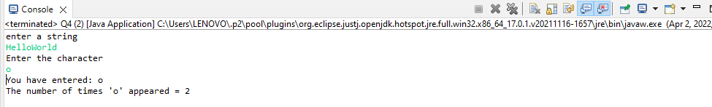

5.Write a program to take an input of a string with multiple words and convert it into a string array,

and check if every element of that array is a Palindrome.

Note: Palindrome is a word which when reversed also is the same.

package SBA_1;

import java.util.Scanner;

public class Q5 {

public static void main(String[] args) {

System.out.println("Enter a String");

Scanner sc=new Scanner(System.in);

String str=sc.nextLine();

String strArray[] = str.split(" ");

System.out.println("String : " + str);

System.out.print("String array : [ ");

for (int i = 0; i < strArray.length; i++) {

System.out.print(strArray[i] + ", ");

}

System.out.print("]"+"\n");

String word;

for(int i=0;i<strArray.length;i++)

{

word=strArray[i];

char[] str1=new char[word.length()];

int count=0;

for(int j=word.length()-1;j>=0;j--)

{

str1[count]=word.charAt(j);

count++;

}

String word2=new String(str1);

if(word.equals(word2))

{

B System.out.println("Palindrome word : "+word);

}

} } }

